1. 
2. We will use CSV file to see Split EIP (Enterprise Integration Pattern) in action.
3. To read CSV file, we need Camel CSV Component.  
   
4. **Jatin**: Before discussing the split(body()), let’s consider other cases then eventually split(body()) for better understanding.
   1. **Case 01**: Reading CSV file and logging it on the console.   
      This case will not talk about the content of the file.  
      Graphical user interface

      Description automatically generated
   2. **Case 02**: Reading CSV File and printing its whole content as a single msg.  
      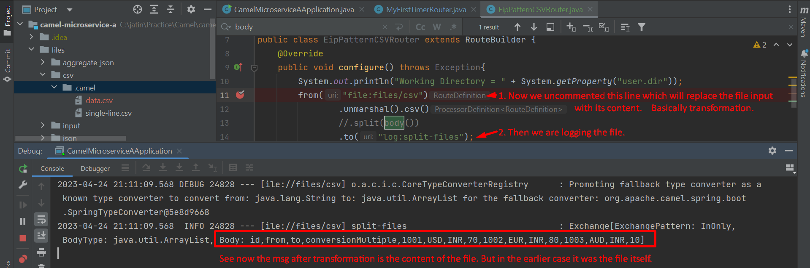
   3. **Case 03**: Reading CSV file and Printing its content each record as a msg.   
      Basically we want to convert each record in CSV file into a separate msg.  
      Text

      Description automatically generated  
      Note in the above slide that each msg is an ArrayList.
5. Let’s understand the case 03 with Active MQ.  
   Application, table

   Description automatically generated  
     
   Graphical user interface

   Description automatically generated with medium confidence
6. So basically, we have a single source and after getting a msg, we’re splitting the msg into multiple msgs and sending to a single channel.   
   That is why is called Split Pattern.